**DAY 03_TASK**

**Assessment 1 - Docker image:**

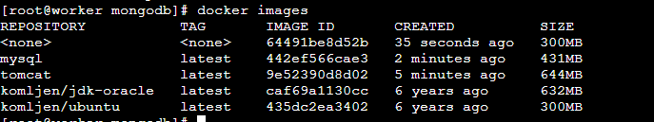

**Assessment 2 – swarm**

**Master and Worker nodes:**



**List of network nodes in worker:**

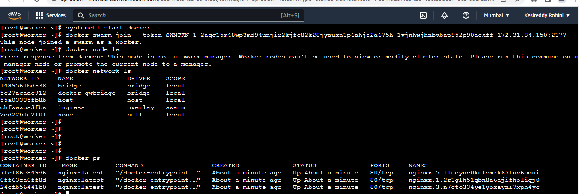

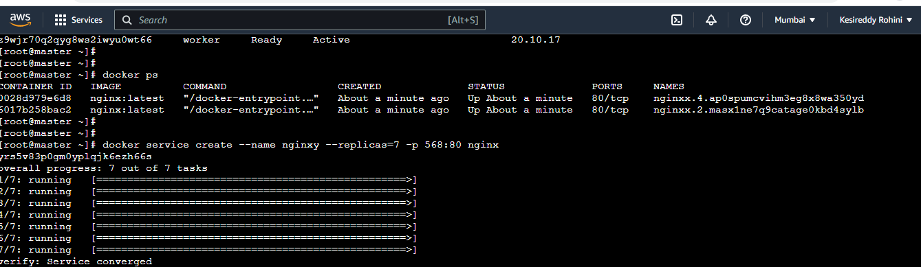

**List of processes in worker:**

